**Negative sampling**

I want a glass of orange juice to go along with cereal

here we will define a context target pair

context-target label

orange-juice is a positive 1

orange-king is negative 0

orange-book 0

and so on picking randomly from dictionary

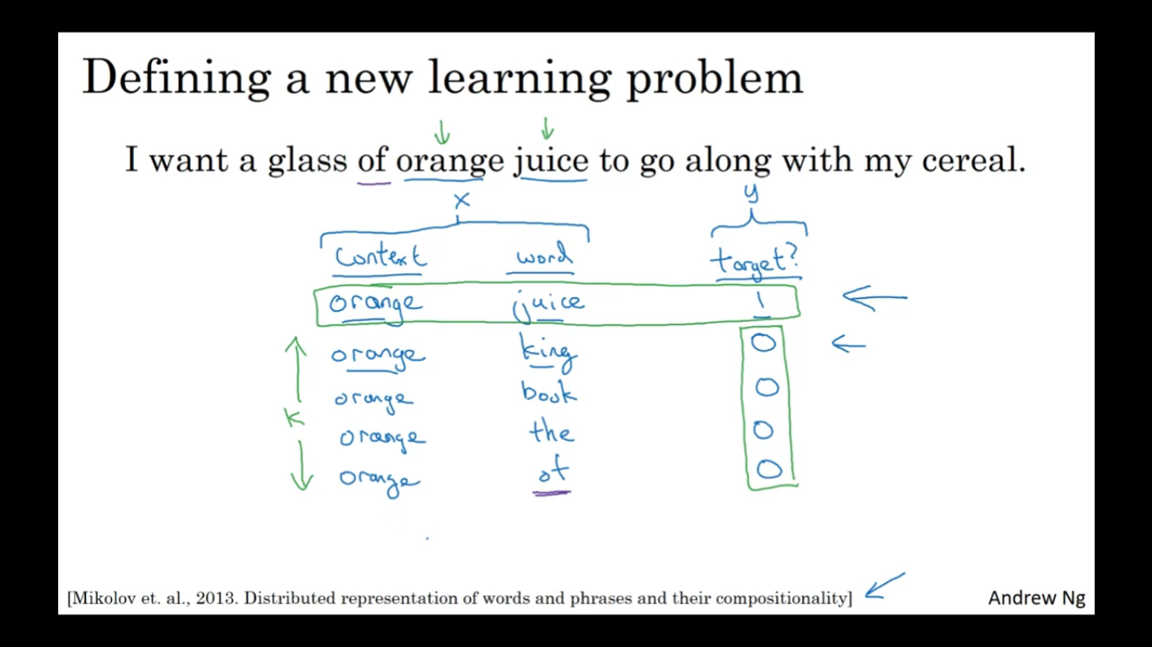

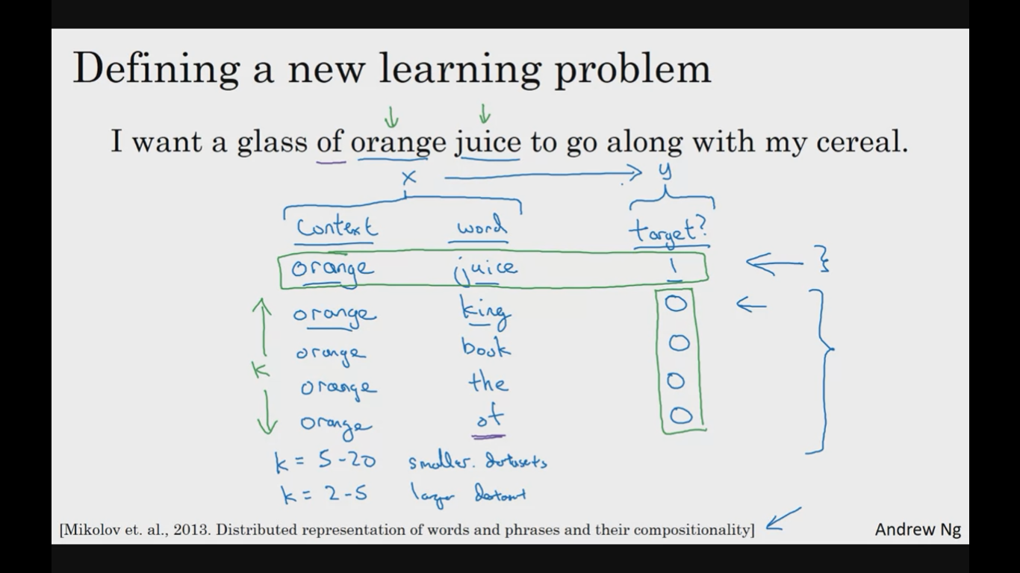

Here instead of having 10000 softmax unit we will use logistic regression model to output is that a positive or negative examples using the context-target pair

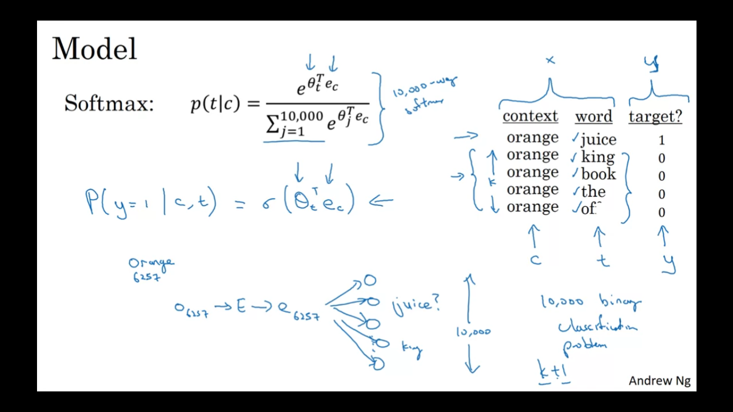

Selecting negative examples:

